A Step-By-Step Guide to Creating a Timeline on HSTRY
Jonathan Ketchell 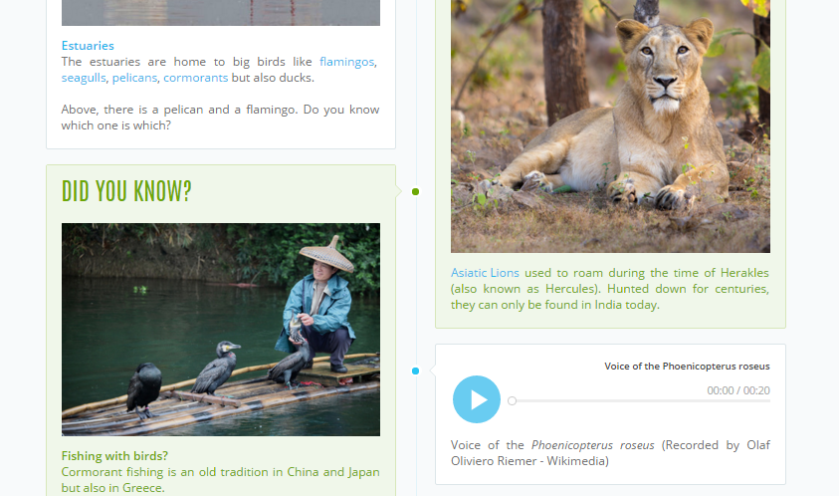
Part I: Introduction
Insert a body of text to introduce what the timeline will be about. It is also here you input the title of the timeline you are creating as well as a banner.
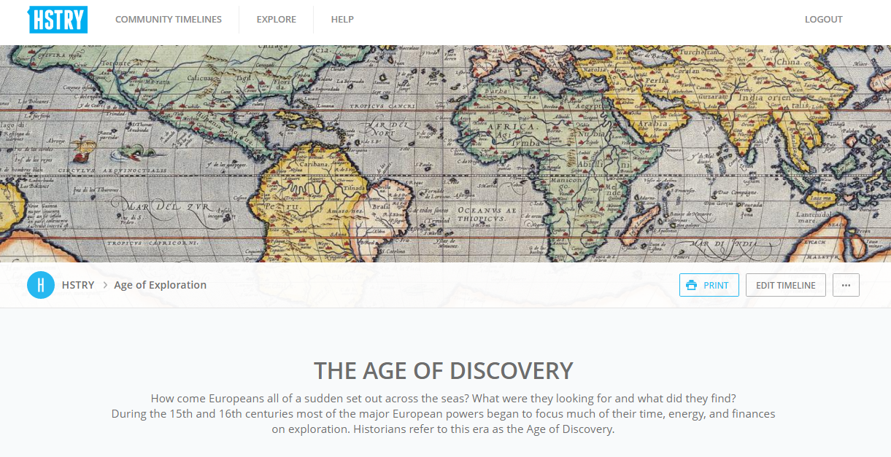
Banner images are perfect for immersing oneself into the timeline
Part II: Main Body
This is the core of your timeline. Here are some general notes to help you:

- Adding an item. Click on the blue plus on the timeline itself. You can then choose the type of item
you want to add. The types of items you can add are discussed on the next page.
2. Editing an item. The general rule for editing an item is simply to click on it. Be it a text box, the
credit note for a photo, a title, or a heading, simply click on it and start typing. By the way, the
application uses the browser's auto-correct functionality (it should be automatically enabled) so
misspelled words will appear underlined.
3. Rich-text Editor. When you click on a text box, you will notice editing options. The options above
enable you to add bold, italics, underline, as well as to include bullet points and hyperlinks. You can
also add notes, small pop ups that appear when you click on them; useful for adding further
explanations or definitions. The interface is very intuitive and similar to what you encounter on
email services or word processors.
- 4. Moving an item. In the bottom right hand corner of each item is a move icon. Click, hold the
- button, and drag the item to where you want in the timeline.
- 5. Deleting an item. To delete an item, click on the red trash can in the bottom right corner. 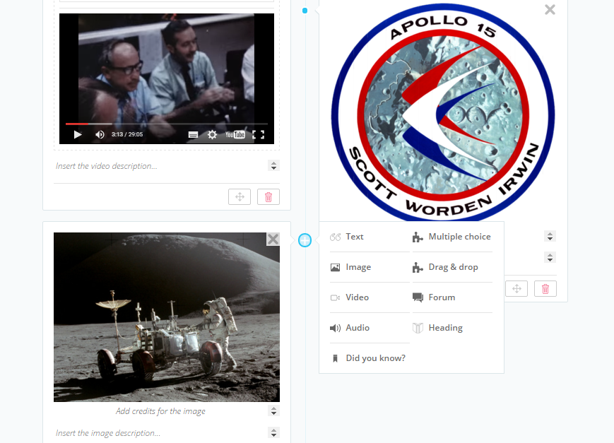
The plus is button in the middle of the timeline is where the magic happens!

TIMELINE ITEMS YOU CAN ADD
- 1. Text item. This is the basic item. It enables you to add, you guessed it right, text. Here like
- anywhere on the timeline, the copy/paste function works.
- 2. Image item. This is the basic text item, plus an image. You can either upload a file from your
- computer or import the link to an image directly from the web by simply entering the web link (the
- content of the address bar at the top of your browser). There are four type of files you can upload:
- jpg, jpeg, gif and png. Every image has a credit line that you can fill in to add the source. To
- remove an uploaded image, use the same trash can icon as for deleting an item.
- 3. Video Item. Add life to timelines by incorporating videos. Currently, it is only possible to share
- videos from YouTube. Copy and paste the link and it will automatically appear. You can also add a
- description below the video.
- 4. Audio Item. Whether you wish to upload a reading, the sound of your own voice, a historical
- recording, radio program, etc., audio files add another dimension to a timeline. Upload mp3 files
- either from your computer or share them from the web by inserting the link.
- 5. 'Did You Know?' Item. A Did You Know item is like an image item. You can add text and an
- image, but the emphasis is on introducing an interesting fact or something that may surprise the
- reader.
- 6. Heading Item. Headings are a great way to structure a timeline and make it more pleasing on the
- eye.
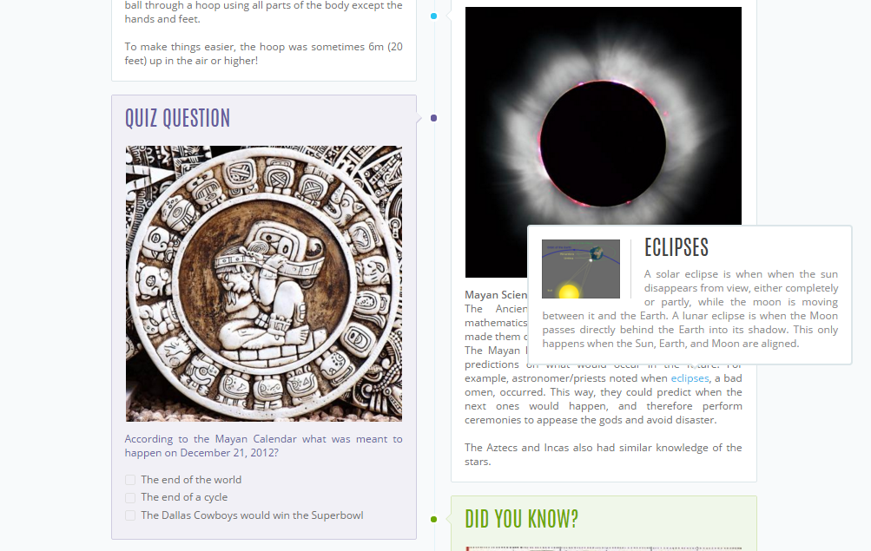
Very quickly, a timeline can look great

Part III: Conclusion and Finishing
A nice way to wrap up a timeline and finish on some more general considerations. It's also a great place to input a bibliography.

Once you've finished the timeline, click on 'View Timeline' to see how it looks. Please note that if you have forgotten to fill in a text box or left something else out, an error message will appear prompting you to fix the issue.

