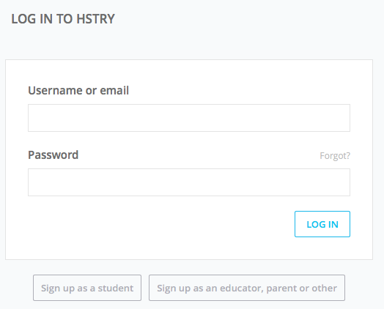
Getting Started with HSTRY

- Go to https://edu.hstry.co/student/register to register for the Teaching Korea HSTRY class.

- Click on Sign up as a student

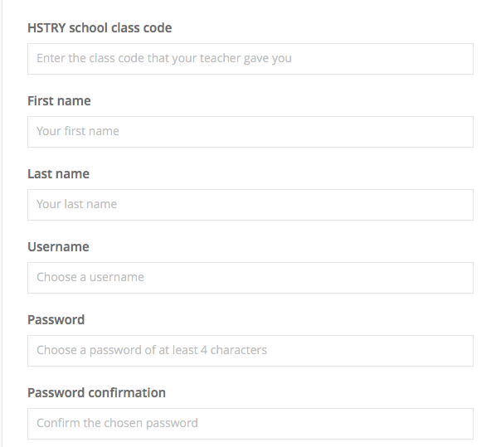

- Fill in all the boxes on the page that appears.
Our HSTRY School Class Code is 24925

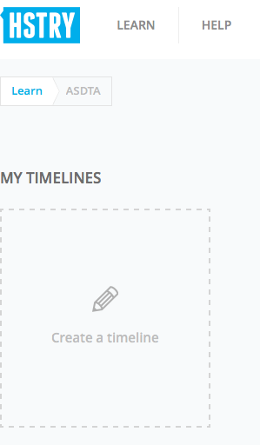

- Click on CREATE A TIMELINE to get started.
A new timeline will appear and you are
ready to create!

